**Modern Data Warehouse  
Final Project**

**Tejas Padavalamane**

**A20543726**

**Introduction to Data Warehousing in Microsoft Fabric**

The Medallion architecture encapsulates core principles such as scalability, modularity, and performance enhancement. It achieves this through a structured layering of data processing tasks, namely Bronze, Silver, and Gold. Each layer serves a distinct purpose in the data pipeline:

* The Bronze layer acts as the initial repository for raw data, aggregating it from diverse sources in its unprocessed state.
* Moving forward, the Silver layer refines and cleanses the data, standardizing it for consistency and reliability.
* Finally, the Gold layer houses curated and processed data, optimized for analytical queries and real-time insights generation.

By adhering to this layered approach, the Medallion architecture provides a systematic framework for ingesting, transforming, and analyzing data, thereby facilitating robust data management and analytics workflows.

**Tools Used:**

Microsoft fabric services:

* Lakehouse
* Synapse Data Engineering
* Notebook
* Schematic model
* Power BI
* Data Pipeline

**Data Source:**

For this project, we utilized data from multiple sources:

1. Sales Data: This includes information about sales transactions such as order details, customer information, product details, and shipping details.
2. Order Priority Data: Information about the priority of orders.
3. Order Return Data: Information about returned orders.
4. Product Data: Information about products.
5. Ship Mode Data: Information about shipping modes.
6. Customer Data: Contains details about customer

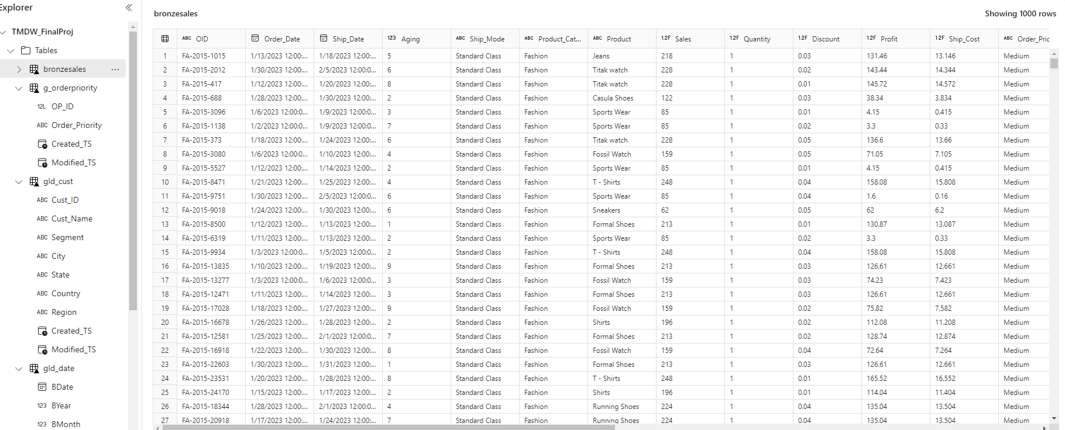

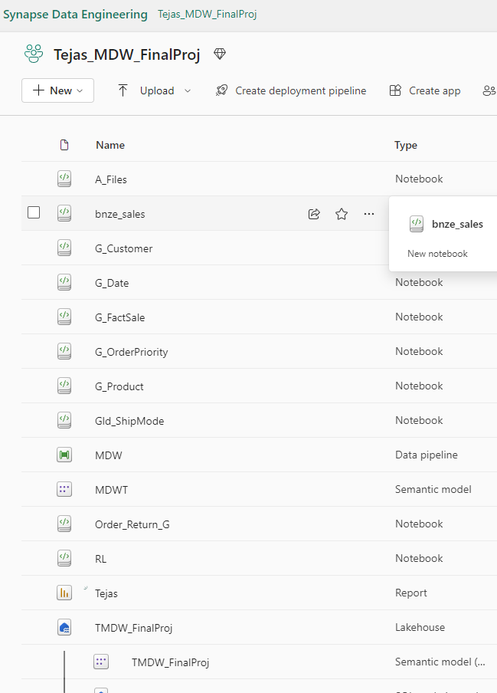

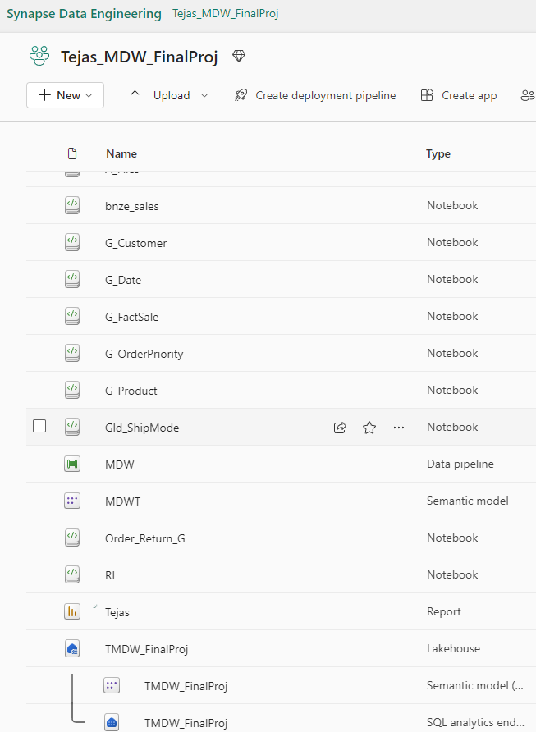

* The above screenshot will display the creation of the Data Lake, tables, and the architecture for all three levels: Bronze, Silver, and Gold.

**Schematic Model:**

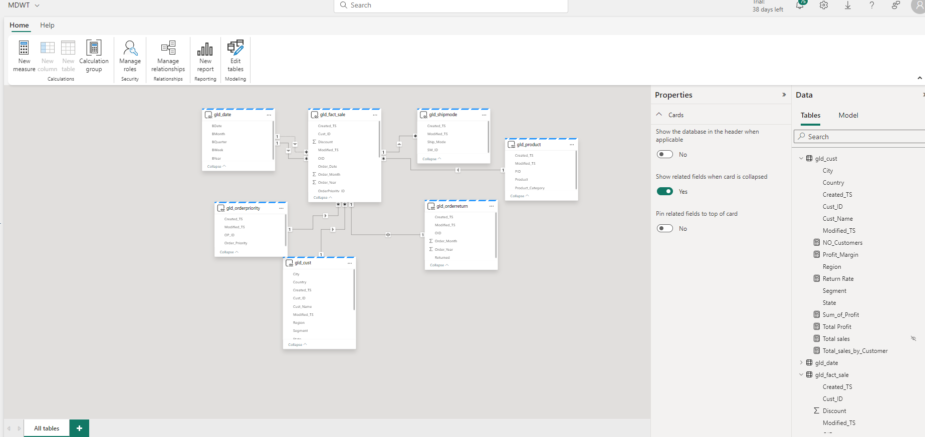

**My Dashboard**

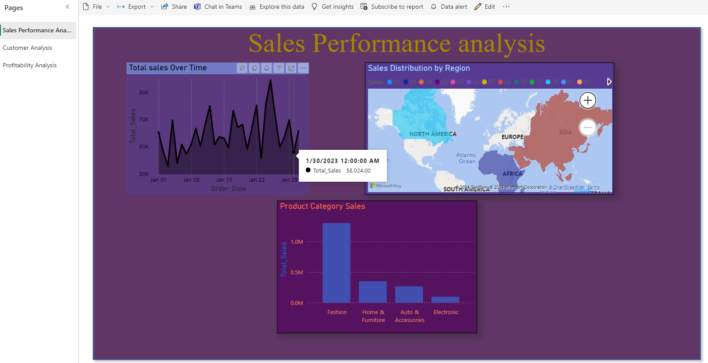

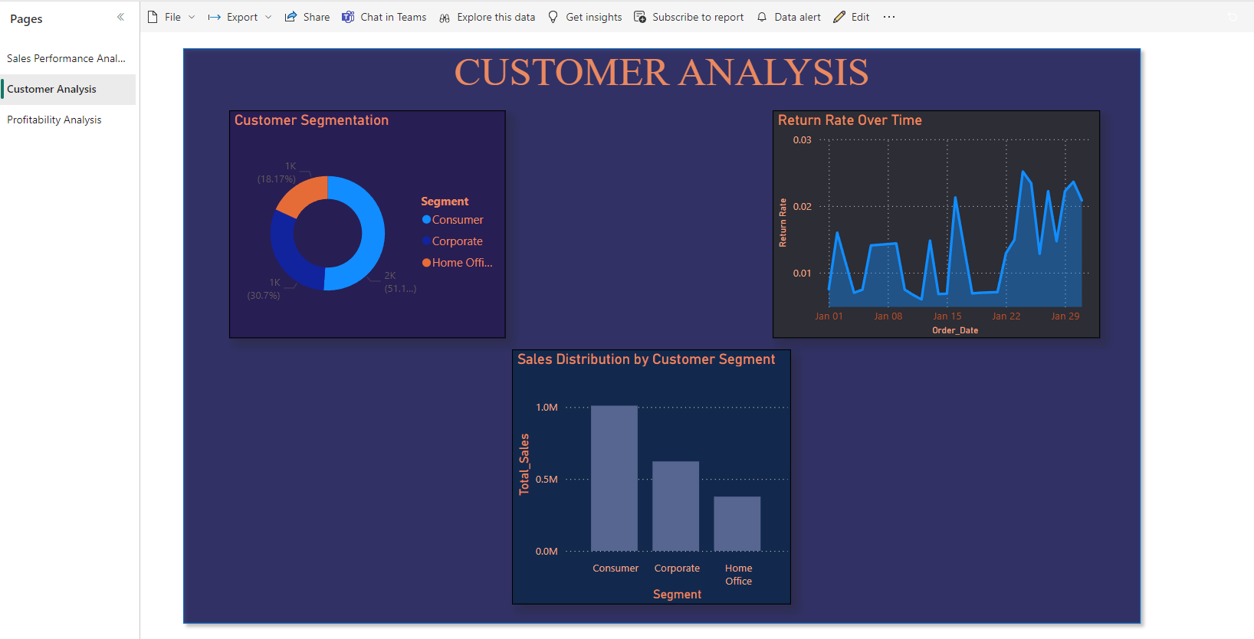

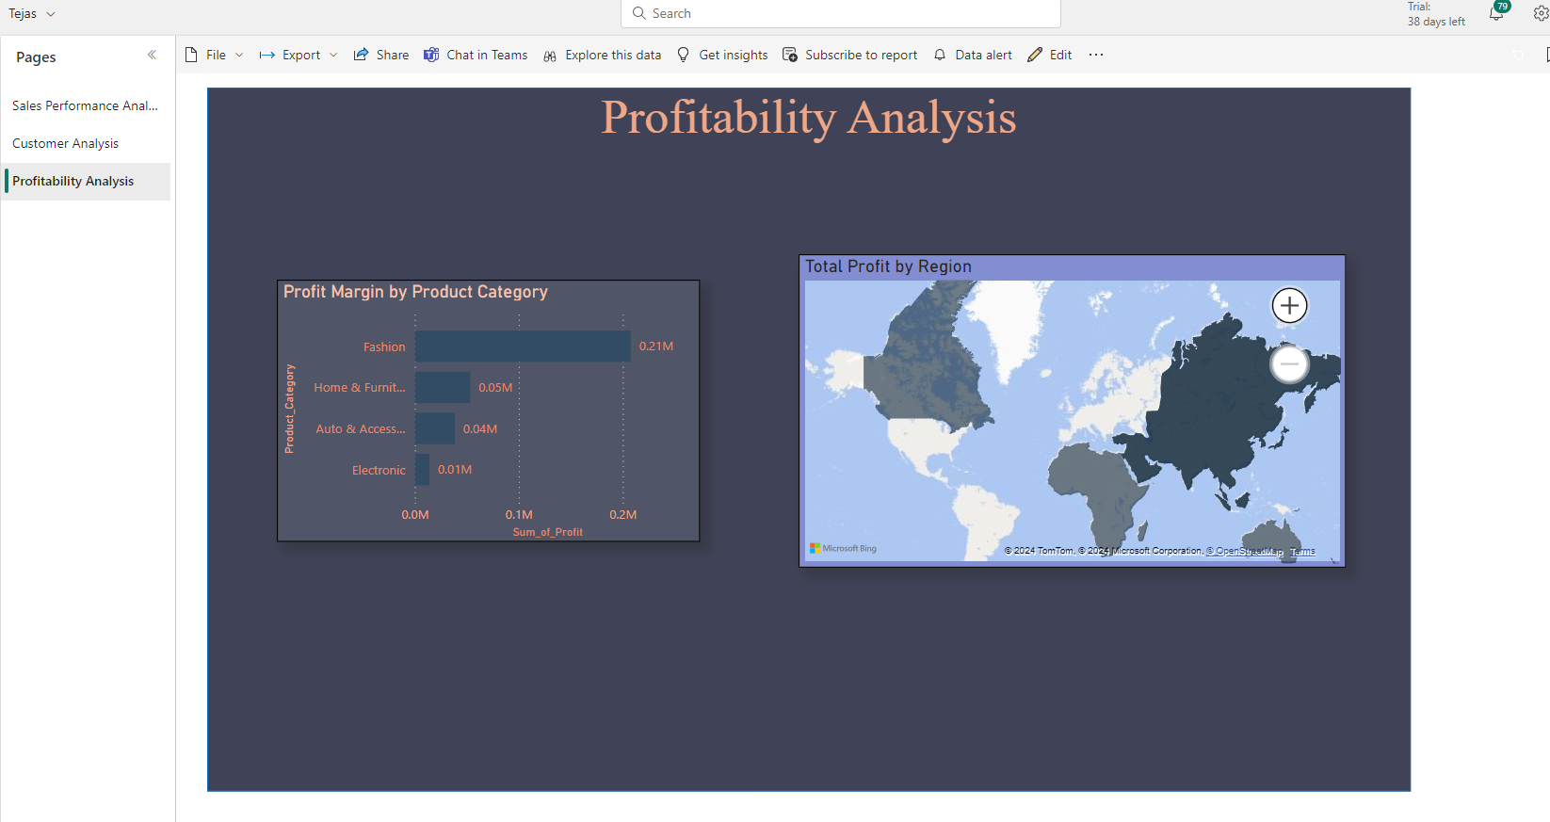

**Code:**









Code zip files are attached.